|  |  |
| --- | --- |
|  | SRAP user documentation |
|  |  |
|  | Joachim Šiškovič  SET Digital Enablement team  3/7/19 |

Table of Contents

Description 3

URL 3

Application Layout 4

Header 4

Main menu 5

Content view 6

Roles 8

Domain structure 9

Domain 9

Subdomain 9

Squad 9

Process 9

Deadlines 9

Reports 10

Squad reports 10

Subdomain report 10

Domain report 10

Initial set up 11

Domain creation 11

Processes definition 12

Deactivating a process 13

Reactivating a process 13

Subdomain creation 13

Deactivate subdomain 14

Reactivate subdomain 14

Squads setup 14

Deactivate a squad 15

Reactivate a squad 15

Defining deadlines 15

Data collecting 17

First phase – Squad reports 17

FP assessments 17

FLL assessment of the squad report 20

Second phase – Subdomain roll-up 21

Third phase – Domain roll-up 22

If you have a Domain Admin role 22

If you have a Domain Owner role 23

History 24

Delegations 25

Viewing my delegators 25

Equations and how calculation works 26

Calculated value for squad report, subdomain report, domain report 26

Rating of calculated value 26

Calculated rating 26

Average of processes for subdomain and domain rollups 27

FLL average for subdomain and domain rollups 27

# Description

SRAP – Security & Risk assessment portal is a tool for collecting security self-assessments for domains. Application has been developed by SET Automation Team. It is deployed on internal IBM Bluemix. Backend has been created using Java framework Spring and frontend with JavaScript framework Vue.js, database hosting all the data is IBM DB2 instance running on Bluemix as a service.

# URL

The can be accessed on this url:

<https://srap.w3ibm.mybluemix.net/srap/index.html>

# Application Layout

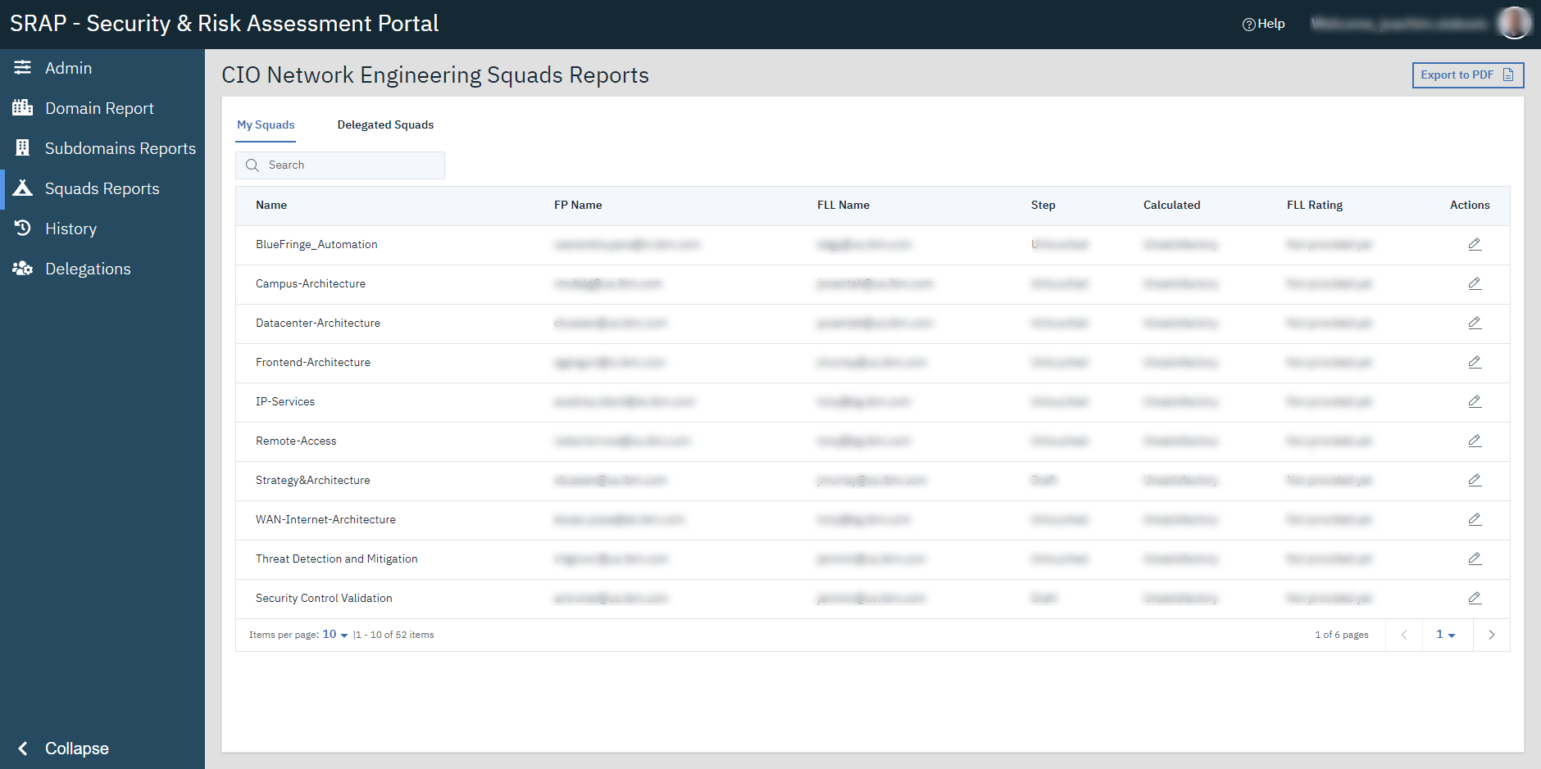

1 Application user interface

Whole application UI consists of three main parts: Header, Main menu, Content view.

## Header



2 Application header

In header you can see application name on the left side, Help link – if it is specified for the domain you belong to, and welcome message with logged in user name and photo from that user Bluepages.

You can interact hover over user name (yellow arrow) to view its user roles list (red arrow) and log out button (purple arrow).

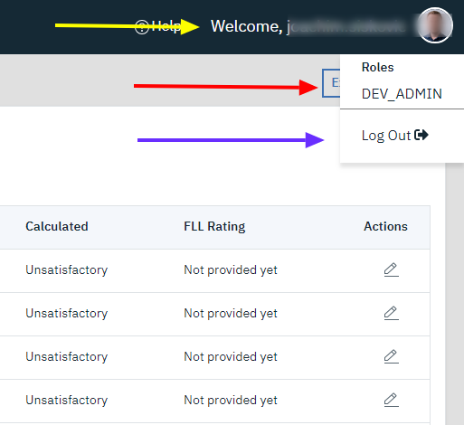

3 User menu shown after hovering mouse cursor above user name in application header

## Main menu

Serves as main navigation for the application. The options in main menu vary depending on the logged in user roles.

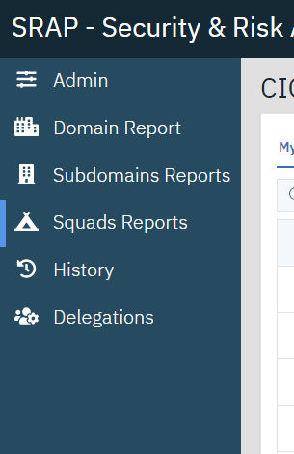

4 Main menu of the application

* Admin – this part is available to these roles: Super Admin, Domain Admin, Dev Admin.
* Domain Report – accessible by: Domain Owner, Domain Admin, Dev Admin.
* Subdomains Reports – accessible by: Domain Owner, Domain Admin, Dev Admin, Second Line Lead
* Squad Reports – accessible by: Domain Owner, Domain Admin, Dev Admin, Second Line Lead, First Line Lead, Focal Point.
* History – accessible by: Domain Owner, Domain Admin, Dev Admin, Second Line Lead, First Line Lead, Focal Point.
* Delegations – accessible by: Domain Owner, Domain Admin, Dev Admin, Second Line Lead, First Line Lead, Focal Point.

At the bottom of Main menu you can find a collapse button that is used to ‘shrink’ menu to a narrower column.



5 Collapse button in main menu

After clicking on it the menu will contain only icons of the respective application views.

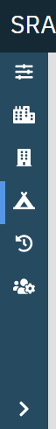

6 Main menu in colapsed state

## Content view

This is the most used part of application as it serves as main view – content here changes based on user location in application.

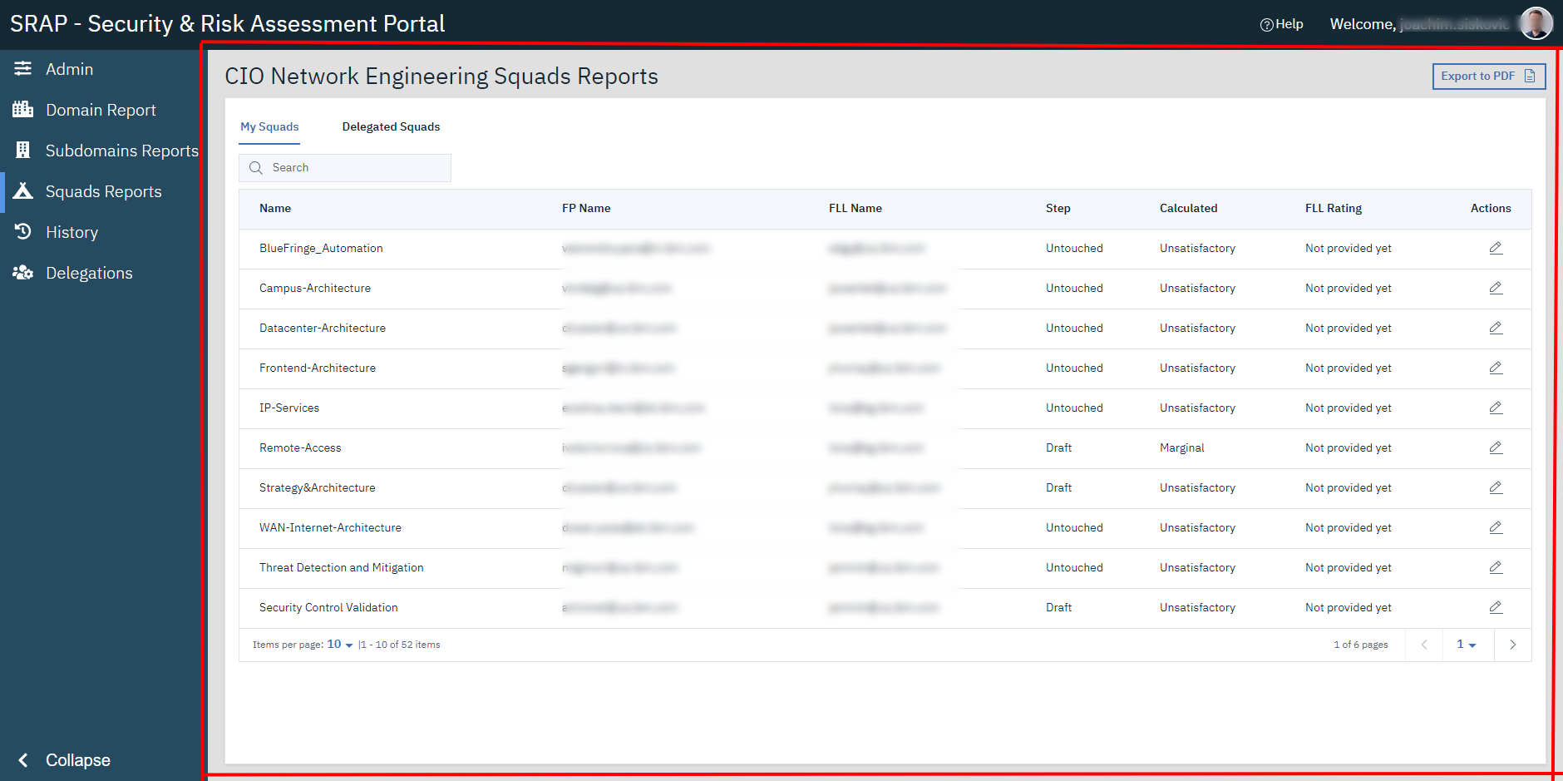

7 Content view

# Roles

Application utilizes several user roles to specify user rights for reading and editing data. This is the list of all roles and respective rights:

* **Super Administrator (SA)** – is above domains and can be specified only directly in DB. He/she can create domains and specify Domain Owner, Domain Administrator and help link for domain.
* **Domain Owner (DO) –** is specified by SA in application in ‘Admin’ section under ‘Domains’ tab. His/her rights include viewing of all reports and editing domain report.
* **Domain Administrator (DA) –** is specified by SA in application in ‘Admin’ section under ‘Domains’ tab. This role is allowed to edit all reports and is responsible for specifying domains squads, subdomains, processes and deadlines. This role is also responsible for specifying squad Focal Point and First Line Lead as well as specifying subdomains Second Line Lead.
* **Second Line Lead (SLL) –** is specified by DA at ‘Admin’ panel in ‘subdomains‘ tab. This person responsibility is to roll up the data provided in squads reports into a subdomain report
* **First Line Lead (FLL) –** is specified by DA at ‘Admin’ panel in ‘squads’ tab. Role of FLL is responsible for filling in FLL override in squad report and signing off the squad report.
* **Focal Point (FP) –** is defined by DA at ‘Admin’ panel in ‘squads’ tab. Only responsibility for FP is to fill in all the data for squad report and submit it for review to FLL.
* Dev Administrator (dev admin) – role for debugging.

# Domain structure

Domain is equivalent of a unit or organization. Each domain can have multiple Subdomains and multiple Squads. Each domain needs also processes defined. It is also recommended to specify deadlines.

## Domain

Domain can be defined by SA in Admin panel under Domains tab. This section is accessible only by SA role. While defining a new domain SA has to specify its name, DA, DO and help link. Domain can be edited in same section.

## Subdomain

Subdomain can be created and edited by DA in admin panel under subdomains section. When creating subdomain DA has to specify its name, and SLL. At least one subdomain is required for each domain.

## Squad

Squad can be created and edited by DA in admin panel under squads section. When creating squad DA has to specify squad name, FLL, FP and choose from existing subdomains to specify hierarchy.

## Process

Processes are the fields for assessment. They are created by DA in admin panel in processes section. For a process to be defined DA needs to specify its name, description – a rule that specifies how FPs should asses their squad for this process – and weight (used for calculation of overall rating). If no process is defined no data can be collected for reports. If process is no longer needed (in new quarter) you can disable it in admin panel.

## Deadlines

Deadlines are defined by DA in admin panel under deadlines section. To define deadlines DA needs to choose a quarter and then define three deadlines: FP submission deadline, FLL Sign-off deadline, Subdomain roll-up deadline. These serve two main uses firstly to specify a date after which the reports are automatically moved to next level (locked for user to fill in the data) and secondly to enable email notifications for users that did not yet finished their action before closing in deadline. These emails are sent 5 and 2 days prior to reaching deadline. The automated lock of report for each dedline happens at 1:00AM GMT (UTC+0).

# Reports

All reports are done quarterly. There are three levels of reports: Squad Reports, Subdomain Reports and Domain Reports.

## Squad reports

Squad reports are the starting point of data collection. Data for squad reports is filled in by FP and after submission validated and signed-off by FLL.

## Subdomain report

Subdomain reports are a first level roll-up reports. Calculation of data is responsibility of SLL. When opening report that does not have a report calculated yet, you will be shown a message that you need to calculate the data first. To calculate data, click on ‘Calculate from collected Data’ button.

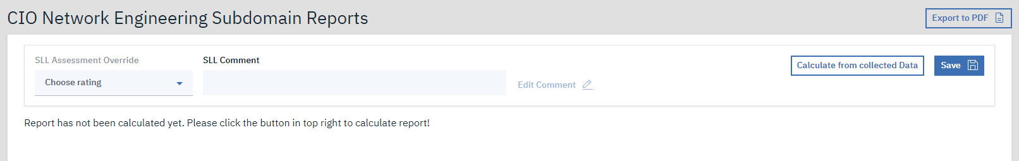

8 empty subdomain report

## Domain report

Domain reports are the second level roll-up reports. Domain reports require to be calculated same as subdomain reports. After calculation DA can to provide comment for each of the calculated average for processes, to explain the value for DO. DO can add his/hers override and comment.

# Initial set up

## Domain creation

To create a domain user with SA role has to log in into application and navigate to admin panel and domains section.

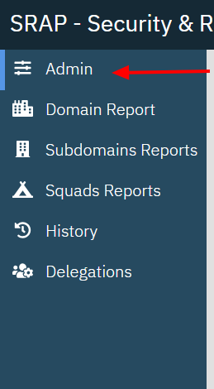

9 navigate to admin panel



10 navigate to domains section

SA will be presented with a table of already created domains. And above at right side there will be a blue ‘Add Domain +’ button. Click it to open new domain dialog.

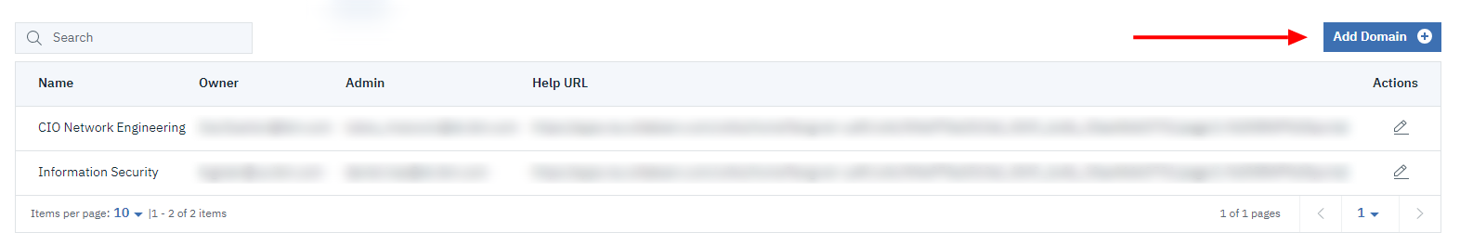11 domain table

After clicking on the button new domain dialog will appear. Fill in the new domain name, add owner and admin for the domain and add help URL provided by either DA or DO. URL must start with ‘http://….’ or ‘https://…’ otherwise the link will not work.

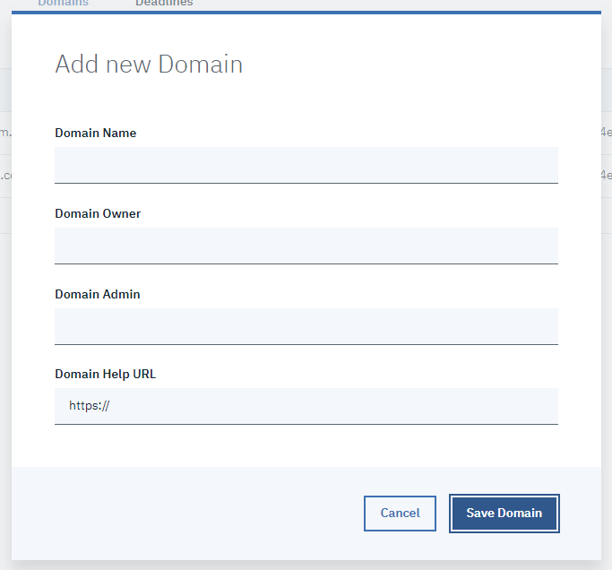

12 fill in the add new domain dialog

After filling in the data, click save to store the domain. Do not worry if you have made a mistake you can edit the domain later by clicking on the pencil icon in the corresponding row in the domains table. This will open the edit domain dialog that looks similar to the add ne domain dialog.

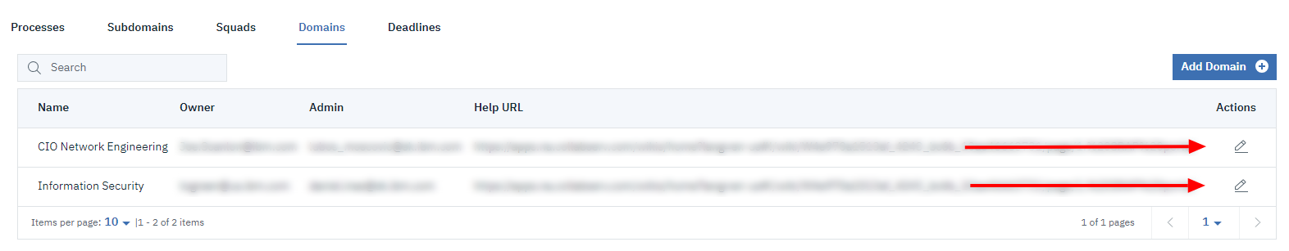13 in domains table click the pencil (edit) icon to update/change the data for domain

## Processes definition

To define or update the processes list for domain. You must have a DA role for your domain. After successful login navigate to admin panel in main menu and click on processes section.



14 navigate to processes section

Here you can see a table of already defined processes. Above the table on the right side you can see blue ‘Add Process +’ button. Click on it to bring up the add new process dialog.

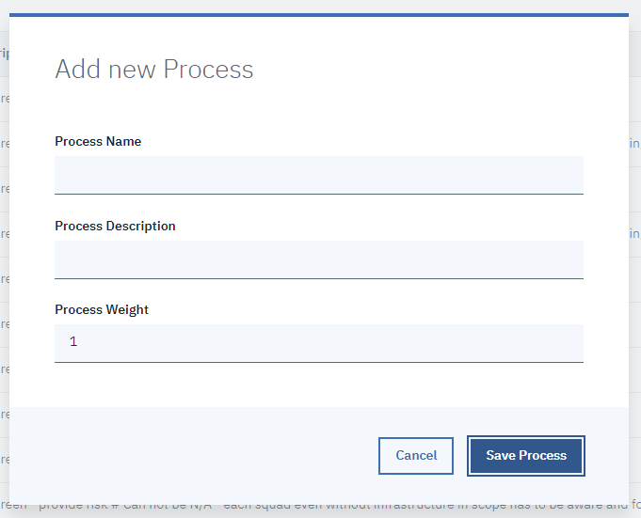

15 add new process dialog

Fill in the process name, process description – this should contain the rules that FP needs to follow when assessing his squad for this process – and process weight – this is numeric value between 1 and 10 (including) and specifies how important the process for your domain is. Higher weight will influence the calculate value for each report more than lover value. After filling in the data click on ‘Save Process’ button. If you made a mistake you can edit the process by clicking on the pencil (edit) icon in corresponding row in processes table.

### Deactivating a process

To deactivate a process, navigate to admin panel and to processes section. In the table of processes you can see a actions column. Click on the icon (disable icon).

### Reactivating a process

To reactivate a deactivated process click on edit icon and click on save button. This will make the process active again.

## Subdomain creation

To create a subdomain you must have DA role. After successful login navigate to admin panel and subdomains section.



16 Navigate to subdomains section in admin panel

Here you will be provided with a subdomains table with already created subdomains in your domain. Above the table on right side there is blue ‘Add Subdomain +’ button. Click it to bring up the new subdomain dialog.

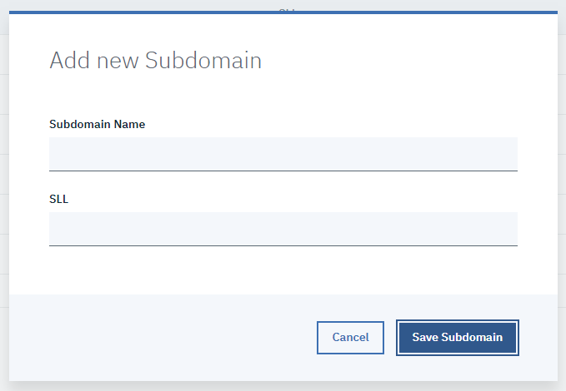

17 Add new Subdomain dialog

Fill in subdomain name and choose a SLL for this subdomain. Than click save button. If you have made a mistake you can edit the subdomain by clicking the pencil (edit) icon in subdomains table in actions column in the specific row.

### Deactivate subdomain

To deactivate a subdomain, click on the disable icon in the row that you want to deactivate.

### Reactivate subdomain

To reactivate a subdomain, click on edit icon and then the save button in edit subdomain dialog.

## Squads setup

To create and modify a squad you need to have DA role. After successful login navigate to admin panel and squads section.

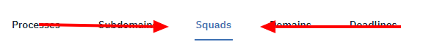

18 Navigate to squads section in admin panel

Here you will be presented with a table of already defined squads. Above the table there is a blue ‘Add Squad +’ button. Click it to open new squad dialog.

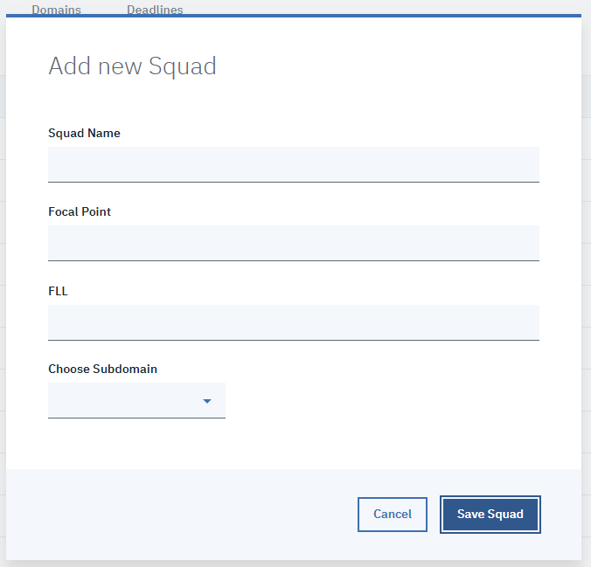

19 Add new Squad dialog

Fill in squad name, choose a FP, choose FLL and choose subdomain from the subdomains dropdown. If you did not yet create a subdomain please return to previous step as each squad needs a parent subdomain. Then click save button to store the squad.

### Deactivate a squad

To deactivate a squad go to squad section in admin panel and click on deactivate icon in specific row in squads table.

### Reactivate a squad

To reactivate a squad go to squad section in admin panel and click on edit icon in specific row in squads table then click on save button in edit squad dialog.

## Defining deadlines

To define or update deadlines set you must have a role of DA. After successful login navigate to admin panel and then open deadlines section. You will see a deadlines table that contains list of previously defined deadlines. Above it on the right side you can see a blue ‘Add Deadline +’ button. Clicking it will bring up new deadline dialog.

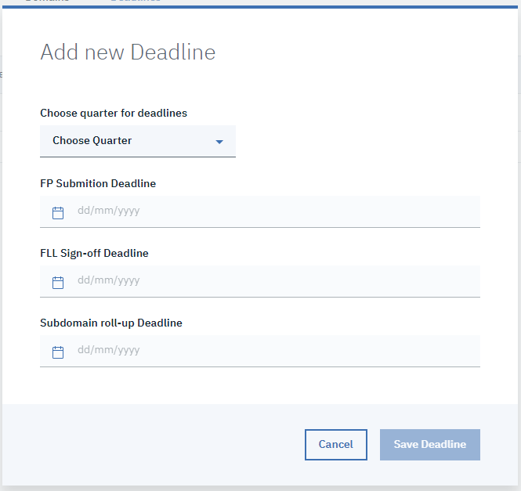

20 Add new Deadline dialog

Choose quarter that you want to define deadlines for. Then set dates for each of the three input fields starting from top to bottom (FP Submission, FLL Sign-off, Subdomain roll-up). Each next deadline for a quarter can be set after the previous one or on the same day, never prior. Last possible date for each deadline is the last day of the quarter.

After filling in the data click on the save button to store the deadline.

To edit the deadline click on the edit icon in the desired row of the deadlines table.

# Data collecting

The next few parts will describe how the data collection for each report works in order. First FP has to asses his/hers squad(s) and submit the report for a review by FLL. FLL will be informed by an email once FP clicks submit button on a squad report. This also locks down the processes input fields for this report, so FP cannot change the data any more.   
After submission FLL can either return the report back to FP if the data does not correspond with reality or sign it off. Each action will send an email to FP informing him either that the report needs to be modified or that it was approved by FLL.

After all the squads reports are signed off second phase starts. This one is about subdomain reports. SLLs have to do a roll-up of their subdomain squads. Firs they have to calculate the data from collected reports and then fill in their comments and save the roll-ups.

After all subdomains reports are closed starts last phase. This phase is about domain roll-ups. This last phase includes actions of DA and DO.

## First phase – Squad reports

Collection of FP assessment and FLL overview

### FP assessments

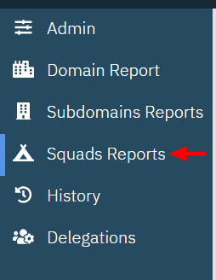

21 navigate to squad reports page

To fill in a squad report FP has to navigate to squads reports page and from squad reports table click on edit icon in squad reports table.

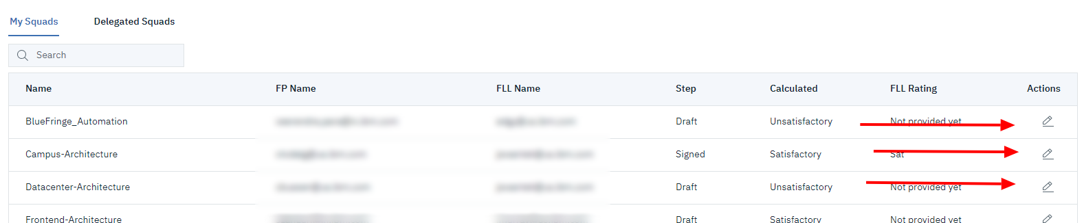

22 click on a edit icon to open a squad report

This is how an empty report looks like

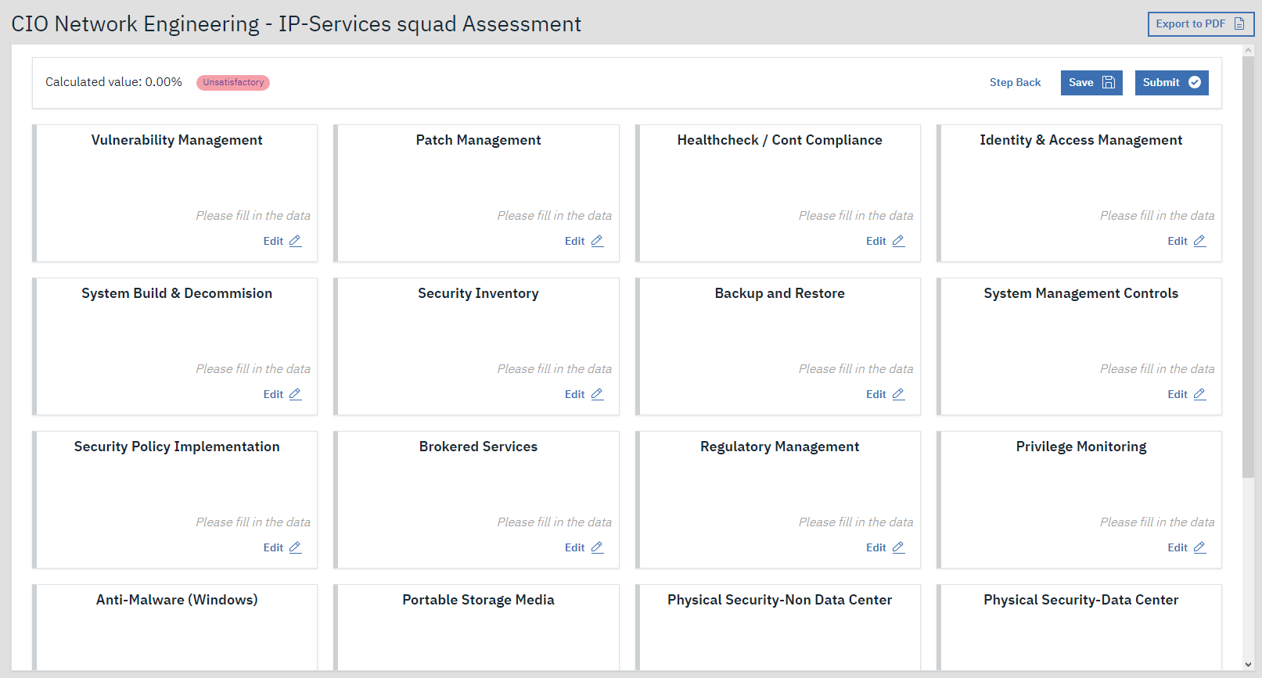23 empty suqad report

FP has to fill in assessment for each of the showing process – represented by a tile. To fill in assessment for a process click on edit button.

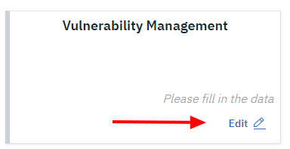

24 click on edit button to open process assessment dialog

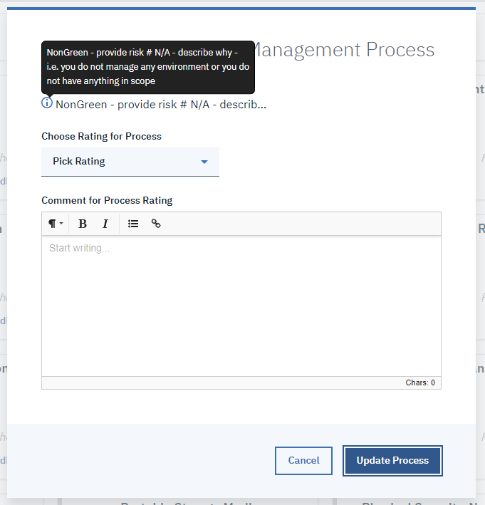

25 process assesment dialog

To view rule for assessment for a process hover over the blue ‘I’ icon below the dialog title. Rating is a mandatory field, if you set it to anything but ‘Satisfactory’ comment field becomes mandatory as well.

Each tile provides a validation information for itself. Left border changes color based on the valid state: GREY is for no data provided, GREEN for correctly filled in fields, RED for an error. The color of the border is also accompanied by a validation message informing you about the state. These are the possible states.

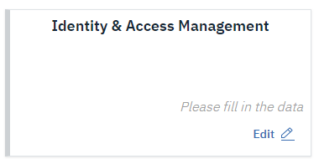 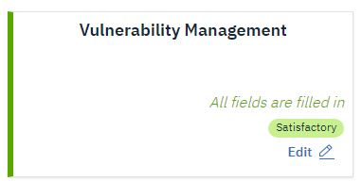 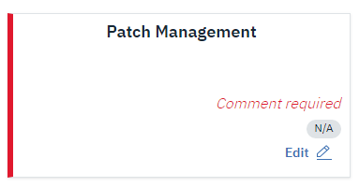 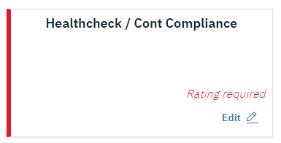

26 left to right top to bottom: Untouched Process, Correctly filled in Process, Missing comment, Missing assesment

Please do not forget to click save button in top right corner of the report, otherwise all the data you have filled in will be lost!

You can save the report at any time, storing your work in progress. To mark squad report as finished you have to click ‘Submit’ button. Be careful about it because once you submit the report you can no longer edit any process assessment. Submitting will also send an automated email to FLL of the squad to inform him/her about the completion of the report. If he considers all your assessments to be correct, FLL will sign off the report and you will receive an automated email about this. If FLL thinks you need to change some value he/she will step it back to you and you will receive email notification about this. These notifications are automated and do not contain any explanation as why FLL has returned report to you. To find out about FLLs reason contact that person.

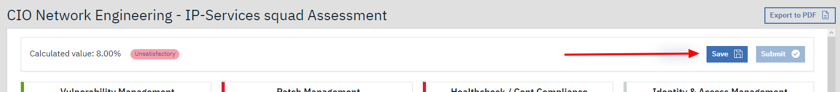

27 Submit and Save buttons in squad report.

### FLL assessment of the squad report

Once FP of your squad submits a report you as FLL of the squad will be notified about the action trough email notification. This is the point when you need to navigate to the report either by link from email, or trough application itself. You can find this report in ‘Squad Reports’ page in squad reports table. To open the report click on the edit icon in the report row. See image figure 22 click on a edit icon to open a squad report.

If the report you opened is already in submitted state you will see a new section between calculated value and process assessments that contains FLL inputs and actions.

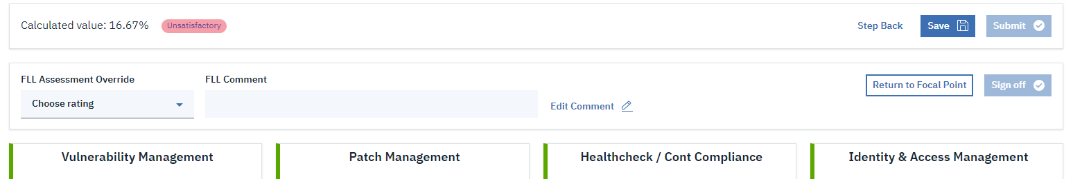

28 FLL input fields

Here you can fill in FLL override to state a difference from calculated value. Then you have to fill in also the FLL comment field to explain your ruling.

If you want to save your inputs and still be able to update it later on click the ‘Save’ button. If you are satisfied with all the inputs you can click the ‘Sign off’ button to sign off the report. This will lock the report for you, so you will not be able to modify anything after this action.

If you spot an issue with some of the processes assessments filled in by FP, for instance that FP marked a process as N/A and you know that the squad should be rated for it, you can perform a step back function by clicking the ‘Return to Focal Point’ button. This will revert the report to Draft state and Focal Point will be informed by automated email that the report has been rejected by you. The automated email does not state why you have rejected the report so you have to inform the FP by yourself about your reasons.

If you have signed off the report this concludes the squad assessment report step.

## Second phase – Subdomain roll-up

After the first phase of data collection is finished second phase starts – subdomain roll-ups. This Phase is handled by SLL.

To access SLL roll-up you have to log in to application and have role of SLL assigned. After successful login you have to navigate to ‘Subdomains Reports’ page in main menu. Here you are presented with the table of subdomains that are assigned to you. To open a report click on the edit icon in actions column.

If the report has not yet been calculated for this quarter you will be shown a message that you first have to calculate the report. To perform this action click on the ‘Calculate from collected Data’ button in top right corner of the report. This will trigger a bit lengthy operation so be patient for the spinner to disappear.

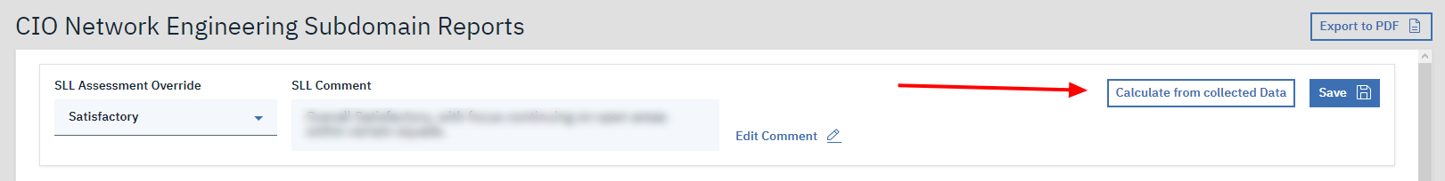

29 Click on the Calculate from collected Data button

After the spinner disappears you will be shown a report with calculated averages for each process across your subdomain.

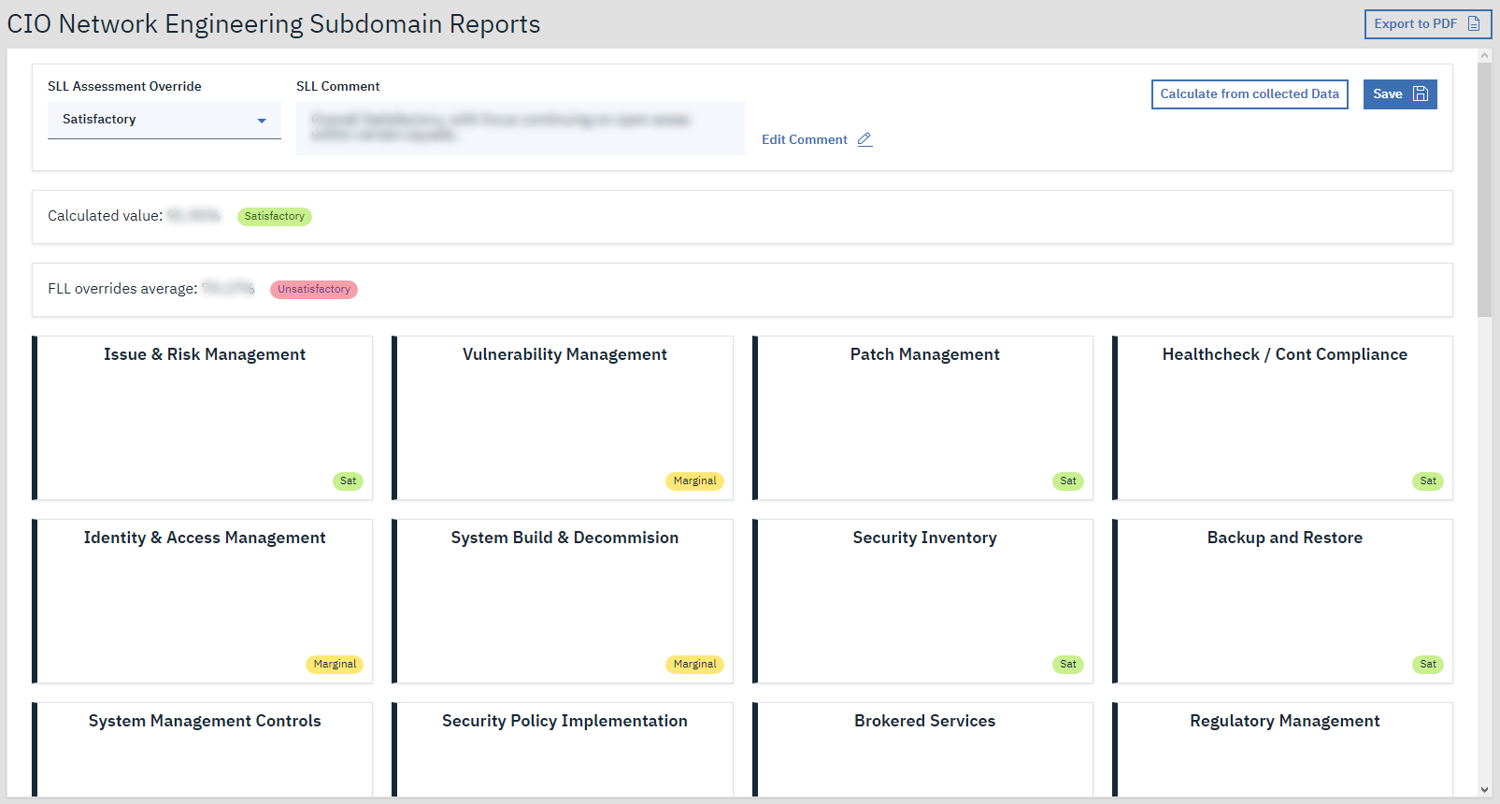

30 Calculated subdomain report

In top sections fill in your override assessment and add a comment. Then click save. The report does not lock for you so you can recalculate the averages if some of the squad report has changed. To recalculate click on the ‘Calculate from collected Data’ button again.

## Third phase – Domain roll-up

This is the last part of quarterly MSAC report.

To access a domain roll-up you need to login as either a DA or DO. After successful login navigate to ‘Domain Report’ page in main menu. If the domain report roll-up has not been calculated yet you will be shown a message stating that you need to calculate the report first before you can be provided with any data. Both DA and DO can perform this action by clicking the ‘Calculate from collected Data’ button in top right corner of the report.

After this action you will be presented with the full report with the calculated data across your domain.

### If you have a Domain Admin role

If you have a DA role you can provide your DO with an explanation for each process average rating. To do so please click on the edit button inside the process assessment card that you want to provide comment for. This will open a comment dialog.

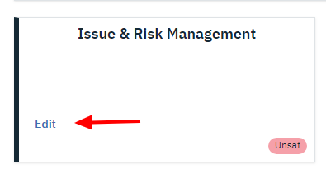

31 Click on Edit button to add a comment for DO

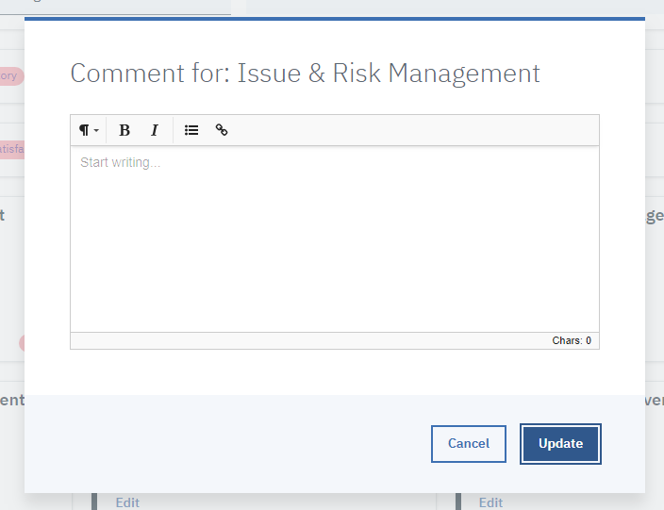

32 Add comment to process average dialog

After you fill in the comments do not forget to press save in the top right corner of the report otherwise the data that you have filled in will be lost!

### If you have a Domain Owner role

If you have DO role assigned you can view the comments provided by your domain DA. This will help you understand why your domain excels in one process but is red in other. Remember that it is up to domain admins to help you with these comments.

You as a DO can now fill in your assessment override and next quarter projection as you see fit. You will also have to fill in domain owner comment field to provide an explanation for future reference.

After you fill in the data please do not forget to click save button in top right corner of the report to store your data in application. If you forget to do so the data that you have filled in will be lost!

# History

History view serves as archive of all collected data. Meaning you can view the old reports from previous quarters. To do so log in into the application and navigate to ‘History’ section in main menu. There you will be presented with a dropdown with previous quarters and a content switcher to choose what level of reports you want to browse.

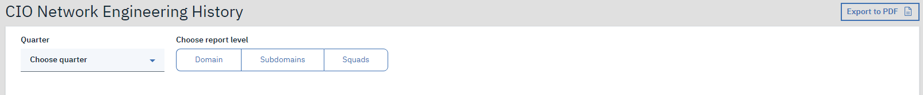

Choose from the quarter dropdown and then click on the report level: Domain, Subdomains or Squads.

Choosing domain will open directly the report for selected quarter. If you choose either Subdomains or Squads you will be presented with a table of all reports for selected quarter. Click on the edit icon in the table to open the desired report. This will open the report.

Opening any report will provide you with the data only without the ability to edit anything as this view is for archiving purposes only.

# Delegations

‘Delegations’ section is used to assign delegates for your role or view delegations that you have been assigned.

To view this you have to first log in and have at least one role assigned. If you have role assigned you can delegate as many users as you want. This will not revoke your rights just add another person that can access same reports as you. This is a feature used for cases when you know you will be unavailable to fill in the reports you are responsible for and want to set a stand in for yourself.

Any delegation that you grant will be in place until you revoke it.

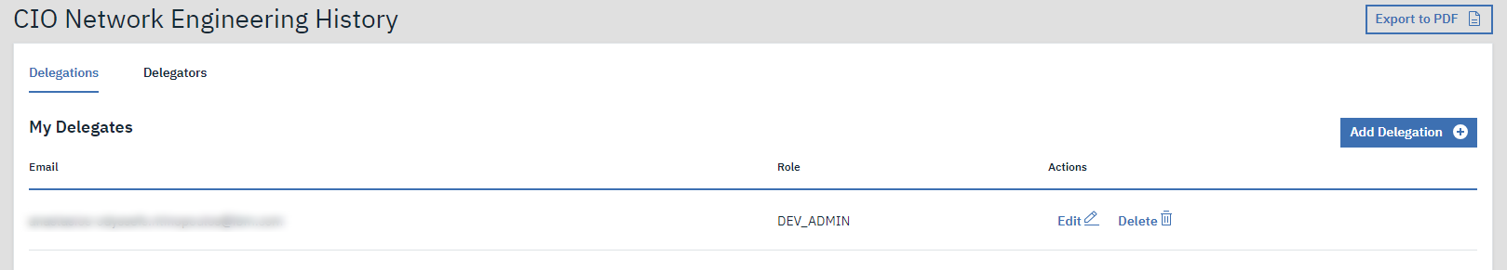

To assign a delegate navigate to Delegations section in main menu and then click on the blue ‘Add Delegation +’ button. This will bring in the ‘Add your Delegate’ modal, where you can choose the IBM employee you want to assign as a delegate and choose from your roles that you want to assign the delegate to.

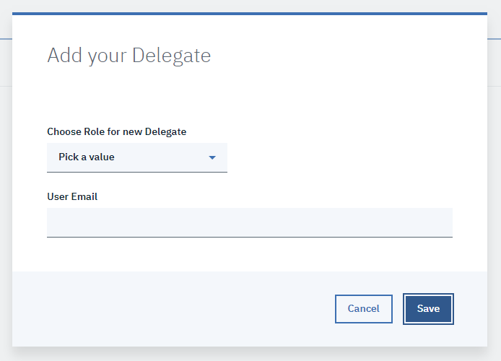

To edit the delegation, click on the edit button in the respective row in the ‘My Delegates’ table.

To revoke a delegation, click on the Delete button in the respective row in the ‘My Delegates’ table.

## Viewing my delegators

To view delegations you have been assigned navigate to delegations page from main menu and then click on the ‘Delegators’ tab. This will show you table of delegations you have been assigned to with the email of your delegator as well as the name of the role you have been assigned.

# Equations and how calculation works

There are several calculations of average values. This section explains how the calculation works.

## Calculated value for squad report, subdomain report, domain report

This is the calculated value that you can find in any report in top left corner. It includes calculated value in percentage and a rating.

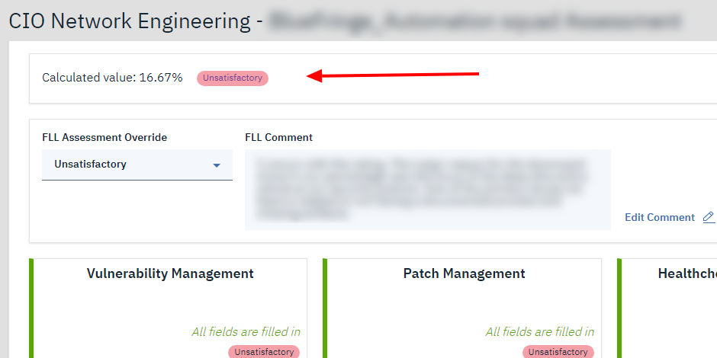

### Rating of calculated value

The rating (SAT, MARGINAL, UNSAT) has a simple rule to be evaluated.

* Satisfactory: calculated value must be 90% or higher
* Marginal: calculated value must be smaller than 90% but higher than 75% (included)
* Unsatisfactory: calculated value is lower than 75%

In intervals it is:

This rule applies for calculated rating for all report levels.

### Calculated rating

Calculated rating is a weighted average from ratings of all processes for each report. Weights for processes are defined by DA in admin panel.

The average is than shown in percentage rounded to second decimal. This calculation is same for all levels of reports for calculated value.

## Average of processes for subdomain and domain rollups

This is an equation that is used to get a average process ratings in either a subdomain for subdomain roll-up report or domain for domain roll-up report. It is using regular average omitting weights of processes at this step.

For each process in a roll-up level of report the average is calculated with this formula

## FLL average for subdomain and domain rollups

This equation is same as previous one. It calculates a regular average for all squads FLL rating in your subdomain/domain.